Asymmetric DCC correlation: AUDUSD and USDJPY
Method 10 / GARCH(1,1) + Cappiello-Engle-Sheppard ADCC / Alpari D1 full available history

Study setup
Logical pair: AUDUSD , USDJPY
Broker symbols: AUDUSD_i , USDJPY_i
Snapshot: 2026-11-03_majors_alpari_D1
Timeframe: D1
Matched return window: 1999-01-05 to 2026-11-02 (UTC bar dates)
Matched return count n: 7199
Dropped unfinished last bar dated 2026-11-03 UTC after a tick-volume check against the prior complete day.
AUDUSD GARCH(1,1): mu=0.000038, omega=0.005421, alpha=0.052450, beta=0.936928
USDJPY GARCH(1,1): mu=0.000110, omega=0.005014, alpha=0.052022, beta=0.935293
ADCC: a=0.054591, b=0.902108, g=0.042052, a+b+g/2=0.977724
Nested DCC (g=0): a=0.060899, b=0.916242
Negative shock: n = min(z, 0) in broker quote direction (not inverted)
Burn-in ignored in path summaries and chart: first 60 updates
Complete matched rows (Excel): AUDUSD-USDJPY_ADCC_D1.xlsx
Complete matched rows (HTML table): AUDUSD-USDJPY_ADCC_D1_data.html

Method carried forward
Asymmetric DCC extends Engle DCC with an extra term on joint negative standardised shocks. Each matched daily log return of close, ln(close_t / close_t-1), is first filtered by a constant-mean GARCH(1,1). Then z = residual / sigma and n = min(z, 0). The Cappiello-Engle-Sheppard recursion uses A = (1-a-b) Q_bar - g N_bar with N_bar = mean(n n'). Quotes are not inverted, so a negative shock is a negative log return in the broker quote. Nested symmetric DCC (g = 0) is fit on the same z path for comparison. Constraints: a,b,g >= 0 and a + b + g/2 < 1. Path summaries ignore the first 60 updates. The headline is latest ADCC rho. Pearson r is a side check only. This is not a cause, lead, or trading signal.

Results
Latest ADCC rho: -0.229616
Latest nested DCC rho: -0.151274
Post-burn-in ADCC path (n=7139): mean=-0.246810, median=-0.298355, min=-0.670225, max=0.746803, std=0.262406
Share of post-burn-in days with |rho| >= 0.4: 36.07%; |rho| >= 0.7: 0.11%
Same-sample Pearson r: -0.088151
ADCC minus r: -0.141465
ADCC minus nested DCC: -0.078342

Conclusion
Over 7199 matched daily log-return rows for AUDUSD and USDJPY (broker quote directions unchanged), latest ADCC rho is -0.2296 (negative, weak conditional linear link in this sample) with fitted a=0.0546, b=0.9021, g=0.0421. Nested symmetric DCC latest rho is -0.1513 (ADCC minus DCC = -0.0783). After a 60-day burn-in, path mean is -0.2468 and std is 0.2624. Same-sample Pearson r is -0.0882 (ADCC minus r = -0.1415). This does not establish cause, lead-lag, or a lasting trading rule.

Charts
Daily closes

Daily log returns
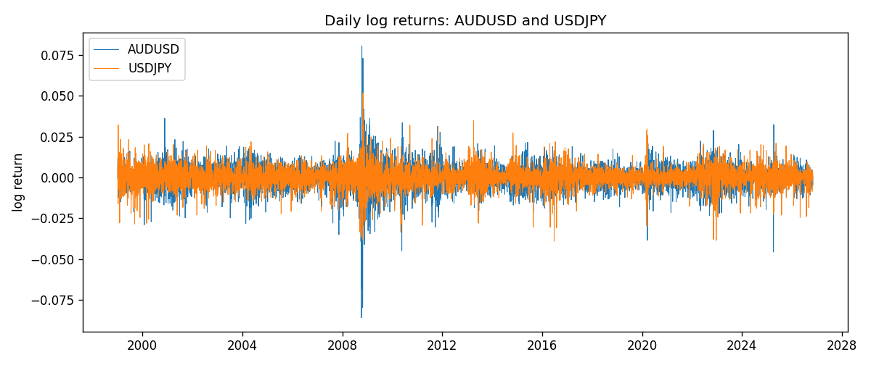
ADCC rho path with nested DCC and Pearson r
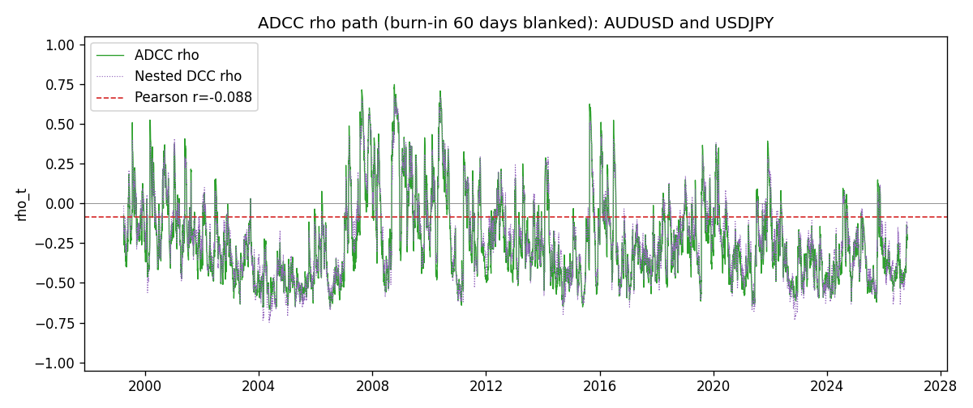

Data report
Every matched row that entered the ADCC recursion is stored in the sibling Excel workbook named AUDUSD-USDJPY_ADCC_D1.xlsx. Embedding all rows as a Word table is impractical at this length; the Word file holds the column list, column summaries, and the first and last 15 matched rows.
Columns: time, AUDUSD_open, USDJPY_open, AUDUSD_high, USDJPY_high, AUDUSD_low, USDJPY_low, AUDUSD_close, USDJPY_close, AUDUSD_tick_volume, USDJPY_tick_volume, AUDUSD_spread, USDJPY_spread, AUDUSD_real_volume, USDJPY_real_volume, AUDUSD_log_return, USDJPY_log_return, AUDUSD_sigma, USDJPY_sigma, AUDUSD_z, USDJPY_z, AUDUSD_n, USDJPY_n, q11, q22, q12, rho_adcc, rho_dcc
Column summaries (matched calculation rows)
column | count | mean | std | min | 25% | 50% | 75% | max
AUDUSD_open | 7199 | 0.75196998 | 0.13527571 | 0.4785 | 0.661035 | 0.73142 | 0.809135 | 1.10284
USDJPY_open | 7199 | 113.81114 | 19.206896 | 75.693 | 104.4285 | 110.984 | 120.6925 | 163.824
AUDUSD_high | 7199 | 0.75602148 | 0.13583632 | 0.4878 | 0.6647 | 0.7349 | 0.815325 | 1.10795
USDJPY_high | 7199 | 114.30872 | 19.268446 | 76.001 | 104.881 | 111.442 | 121.26 | 163.978
AUDUSD_low | 7199 | 0.7479145 | 0.13459018 | 0.4775 | 0.6577 | 0.72758 | 0.80425 | 1.0975
USDJPY_low | 7199 | 113.28779 | 19.134887 | 75.402 | 103.89 | 110.53 | 120.17 | 163.628
AUDUSD_close | 7199 | 0.75202255 | 0.13525884 | 0.4786 | 0.661195 | 0.73175 | 0.809235 | 1.10169
USDJPY_close | 7199 | 113.824 | 19.222288 | 75.811 | 104.42 | 111.025 | 120.687 | 163.851
AUDUSD_tick_volume | 7199 | 77366.826 | 138149.99 | 109 | 5440 | 43349 | 71344.5 | 1234623
USDJPY_tick_volume | 7199 | 106151.62 | 179316.41 | 197 | 9927 | 53098 | 92761 | 1803508
AUDUSD_spread | 7199 | 30.814558 | 16.886804 | 0 | 13 | 30 | 50 | 50
USDJPY_spread | 7199 | 20.321434 | 17.631726 | 0 | 6 | 11 | 30 | 50
AUDUSD_real_volume | 7199 | 5.2435469e+09 | 1.2539788e+11 | 0 | 0 | 0 | 0 | 3.811512e+12
USDJPY_real_volume | 7199 | 3.470603e+10 | 1.6078743e+11 | 0 | 0 | 0 | 0 | 3.8834203e+12
AUDUSD_log_return | 7199 | 2.78e-05 | 0.00754502 | -0.08602525 | -0.00385397 | 0.00028846 | 0.00415332 | 0.0806166
USDJPY_log_return | 7199 | 4.761e-05 | 0.00620532 | -0.03908203 | -0.00320306 | 0.00011368 | 0.00340781 | 0.05184024
AUDUSD_sigma | 7199 | 0.00693999 | 0.00279439 | 0.00390781 | 0.00551245 | 0.00627103 | 0.00758652 | 0.03855342
USDJPY_sigma | 7199 | 0.00599245 | 0.00173986 | 0.00337295 | 0.00477751 | 0.0056926 | 0.00679212 | 0.01882923
AUDUSD_z | 7199 | -0.00471671 | 1.0001103 | -8.4778463 | -0.60293061 | 0.04002593 | 0.63668686 | 5.0095292
USDJPY_z | 7199 | -0.00896639 | 1.0002805 | -6.5291937 | -0.56466322 | 0.00059696 | 0.58102451 | 7.1033166
AUDUSD_n | 7199 | -0.38816246 | 0.62447993 | -8.4778463 | -0.60293061 | 0 | 0 | 0
USDJPY_n | 7199 | -0.37439074 | 0.62361897 | -6.5291937 | -0.56466322 | 0 | 0 | 0
q11 | 7199 | 1.000412 | 0.4075637 | 0.46301272 | 0.77092995 | 0.91476352 | 1.1118427 | 7.694404
q22 | 7199 | 1.0008795 | 0.43959714 | 0.35026218 | 0.73340008 | 0.89405304 | 1.1352629 | 4.7985587
q12 | 7199 | -0.20935265 | 0.32495473 | -1.5278194 | -0.39051454 | -0.25701654 | -0.10737895 | 2.6544815
rho_adcc | 7199 | -0.24655389 | 0.26179699 | -0.67022524 | -0.44286156 | -0.29792148 | -0.1155733 | 0.74680268
rho_dcc | 7199 | -0.22521948 | 0.25918533 | -0.74824544 | -0.41789961 | -0.26284975 | -0.08417275 | 0.67180216
First 15 matched rows (selected columns)
time | AUDUSD_log_return | USDJPY_log_return | AUDUSD_z | USDJPY_z | AUDUSD_n | USDJPY_n | q11 | q22 | q12 | rho_adcc | rho_dcc
1999-01-05 | -0.00080418179 | -0.00017868311 | -0.13443638 | -0.025685674 | -0.13443638 | -0.025685674 | 1 | 1 | -0.2093086 | -0.2093086 | -0.2093086
1999-01-06 | 0.011836351 | 0.0075660159 | 1.9314277 | 0.6852241 | 0 | 0 | 0.92442295 | 0.92322687 | -0.20336403 | -0.2201327 | -0.20895779
1999-01-07 | 0.0088650256 | -0.012851583 | 1.3491885 | -1.2131902 | 0 | -1.2131902 | 1.0581438 | 0.8795376 | -0.12608637 | -0.1306979 | -0.10339195
1999-01-08 | 0.00031515916 | -0.0047719894 | 0.041491112 | -0.45326324 | 0 | -0.45326324 | 1.0745003 | 0.95673478 | -0.2179777 | -0.2149874 | -0.19121451
1999-01-11 | 0.0072213815 | -0.016195423 | 1.1024396 | -1.5530053 | 0 | -1.5530053 | 0.98997759 | 0.90398825 | -0.21254485 | -0.22467592 | -0.19143564
1999-01-12 | -0.0048608485 | 0.032310364 | -0.74673669 | 2.9714998 | -0.74673669 | 0 | 0.97998316 | 1.0696356 | -0.30008173 | -0.29309764 | -0.27122073
1999-01-13 | -0.0078902098 | 0.0081373171 | -1.2215737 | 0.62633003 | -1.2215737 | 0 | 0.95850848 | 1.468008 | -0.40671783 | -0.34287121 | -0.32006948
1999-01-14 | -0.002696916 | 0 | -0.41556678 | -0.0087416711 | -0.41556678 | -0.0087416711 | 1.0294609 | 1.366772 | -0.42354995 | -0.3570686 | -0.33946391
1999-01-15 | 0.007123101 | 0.0055343401 | 1.0998255 | 0.44619162 | 0 | 0 | 0.965943 | 1.2540384 | -0.39661542 | -0.36036154 | -0.33488051
1999-01-18 | 0.00094592471 | 8.7600193e-05 | 0.14004842 | -0.0018664528 | 0 | -0.0018664528 | 0.9579871 | 1.1632014 | -0.34587917 | -0.32765525 | -0.29196069
1999-01-19 | 0.0072225153 | -0.0056219403 | 1.1361147 | -0.49944248 | 0 | -0.49944248 | 0.88584687 | 1.0703886 | -0.32691336 | -0.33572417 | -0.28998129
1999-01-20 | 0.0012507819 | -0.0053879917 | 0.19010801 | -0.49096556 | 0 | -0.49096556 | 0.89016129 | 1.0107681 | -0.340766 | -0.35924948 | -0.30773872
1999-01-21 | 0.00078094498 | 0.0084664056 | 0.11937277 | 0.76493573 | 0 | 0 | 0.82556295 | 0.95617253 | -0.32738177 | -0.36847775 | -0.30867774
1999-01-22 | -0.012252745 | 0.0060412564 | -2.0233263 | 0.5512993 | -2.0233263 | 0 | 0.76609323 | 0.91556852 | -0.30522764 | -0.36444971 | -0.29469205
1999-01-25 | -0.0039591468 | -0.0073594164 | -0.60925464 | -0.71021229 | -0.60925464 | -0.71021229 | 1.1073081 | 0.86358865 | -0.35112075 | -0.35906147 | -0.32051861
Last 15 matched rows (selected columns)
time | AUDUSD_log_return | USDJPY_log_return | AUDUSD_z | USDJPY_z | AUDUSD_n | USDJPY_n | q11 | q22 | q12 | rho_adcc | rho_dcc
2026-10-13 | 0.0035007712 | -0.0018932826 | 0.76667439 | -0.41108327 | 0 | -0.41108327 | 0.77317763 | 0.57013739 | -0.27157629 | -0.40903686 | -0.35331691
2026-10-14 | -0.0015193215 | 7.5800166e-05 | -0.34566632 | -0.0070830146 | -0.34566632 | -0.0070830146 | 0.75014601 | 0.55171238 | -0.2770751 | -0.43069342 | -0.36518779
2026-10-15 | -0.0075447063 | -0.0018524319 | -1.7092866 | -0.41896331 | -1.7092866 | -0.41896331 | 0.7088285 | 0.51876428 | -0.26459381 | -0.43633902 | -0.35755583
2026-10-16 | 0.0033906408 | -0.00037976126 | 0.71495396 | -0.10626579 | 0 | -0.10626579 | 0.94236559 | 0.50600042 | -0.18436234 | -0.26698512 | -0.24813556
2026-10-19 | 0.0050859986 | 0.0034946841 | 1.0827582 | 0.75024021 | 0 | 0 | 0.89858844 | 0.47861366 | -0.18534107 | -0.28261727 | -0.24867056
2026-10-20 | 0.0034620426 | -0.0022546642 | 0.72602668 | -0.52688684 | 0 | -0.52688684 | 0.89519248 | 0.48354349 | -0.13773081 | -0.2093414 | -0.15821325
2026-10-21 | 0.0036066384 | -0.00032883504 | 0.7609014 | -0.098990112 | 0 | -0.098990112 | 0.85690424 | 0.48409272 | -0.16000969 | -0.24843676 | -0.18842213
2026-10-22 | -0.0012672558 | -0.0085942669 | -0.27933027 | -2.0038195 | -0.27933027 | -2.0038195 | 0.825195 | 0.45870623 | -0.16333669 | -0.26548386 | -0.19175598
2026-10-23 | 0.0023765656 | 0.00035080446 | 0.50944689 | 0.05129837 | 0 | 0 | 0.77252398 | 0.82290676 | -0.10813253 | -0.13562042 | -0.11342448
2026-10-26 | -0.0032032829 | 0.0041238746 | -0.71444668 | 0.87255615 | -0.71444668 | 0 | 0.73163674 | 0.76354961 | -0.11099938 | -0.14850947 | -0.11304147
2026-10-27 | 0.0016669876 | 0.0027651658 | 0.36098218 | 0.57762248 | 0 | 0 | 0.72991351 | 0.75142231 | -0.14904384 | -0.20125018 | -0.16151268
2026-10-28 | 0.0040915541 | -0.00095679538 | 0.91175475 | -0.23477837 | 0 | -0.23477837 | 0.68614286 | 0.71713337 | -0.13794965 | -0.19665879 | -0.14201823
2026-10-29 | -0.0040915541 | -0.00038043789 | -0.92501741 | -0.10998403 | -0.92501741 | -0.10998403 | 0.68492451 | 0.673314 | -0.15101 | -0.22236966 | -0.1574248
2026-10-30 | 0.0010102376 | -0.0010596481 | 0.21690381 | -0.26764101 | 0 | -0.26764101 | 0.72113737 | 0.62962621 | -0.14127397 | -0.20965816 | -0.14449471
2026-11-02 | -0.0049184984 | 0.0026438521 | -1.1243734 | 0.59035154 | -1.1243734 | 0 | 0.67368056 | 0.59596878 | -0.14549231 | -0.22961554 | -0.15127388

